Some helpful links:

<https://clevertap.com/blog/best-conversion-rate-for-mobile-app-downloads/>

Notes:

Facebook adds:

* 20$ = Estimated 886 - 2.6K [people](https://www.facebook.com/business/help/283579896000936) reached per day
* 50$ = Estimated 2.2K - 6.4K [people](https://www.facebook.com/business/help/283579896000936) reached per day

13.08 percent conversion rate with regard to app installs

Instagram adds:

* Same as Facebook? Will double check

Tiktok adds:

* 50$ = Estimated 4.1k - 9.1k views per day

Photography campaign to promote apps?

Promotional video shoot (see video script in folder)

Photographer 75 - 150 per hour (could also do it myself maybe?)

Pay an amateur? 25 to 50? (will confirm)

Billboard?

Depends on location

* Time square starts at 10k

App store optimization?

SEO for website?

Social media marketing agency/ team?

Podcast now emerging market reach out to hosts?

**Acquisition stage:**

**User acquisition strategy**

Paid marketing - app store search adds via apple or google stores (CPI)

UAP universal add campaign via google and or Facebook even LinkedIn

In-app adds on other apps

**Press release:**

* Articles to major journals websites influencers etc
* Use micro-influencers relevant to the app
* blogs

Submit app to review sites hold a lot of weight in the tech community

* App Store reviews are important (need to include review prompt in app)

Do we need a Tiktok manager? Can i do this myself?

**Regarding the stickers…**

* *We already have them need to do something with the remaining ones*
* Can we reliably give to friends to put up?
* Do they stay up?
* Can we shoot a promotional video with them? Covering a wall in them or something?
* Should we just mail them to new users? Or use them as “prizes”

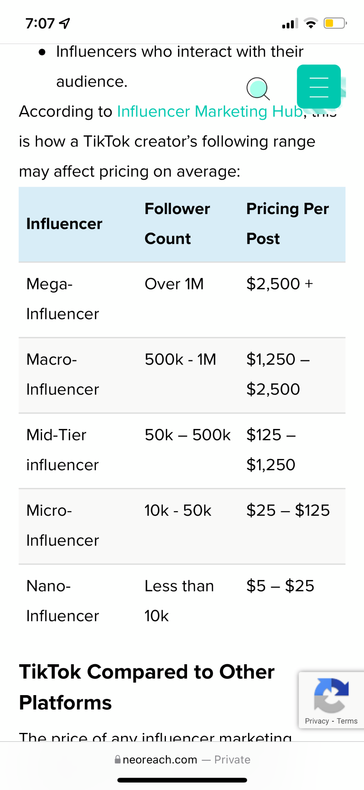

Assuming we find niche creators we want to work with prices ^

13.08 percent conversion rate with regard to app installs